Name__________________________________________Date___________________
Directions: Complete the Success Wheel Using Measure Your Success at the end of Chapter 1. 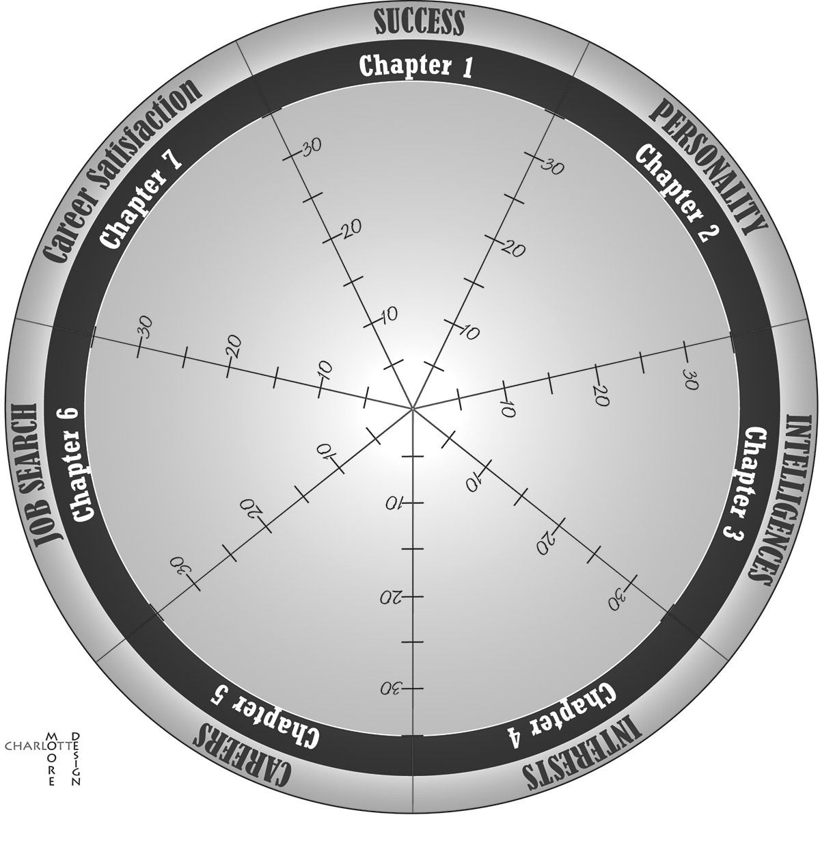
What are your best areas?
What areas do you need to improve?

